Maple Class Topic Homework – The Great Fire of London
Draw a street in 1666 and label  things that helped the fire spread:  wooden houses, narrow streets, open  fires, etc.  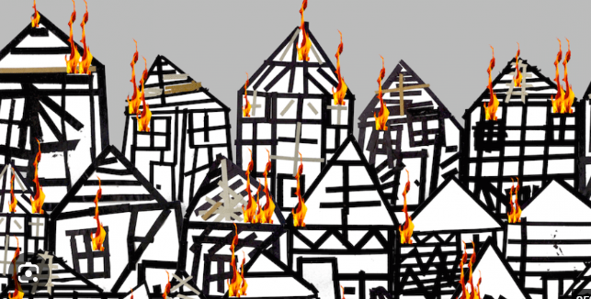 | Build a Fire Engine  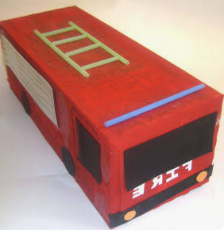  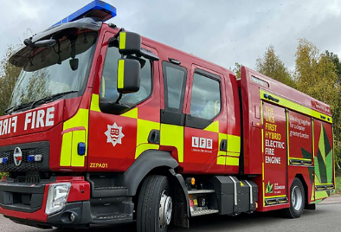 | Become a baker just like Thomas Farriner and bake some bread.  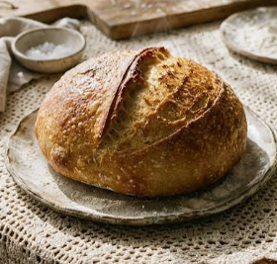
Create a fire collage using different materials. You could use magazine, newspaper or tissue paper.  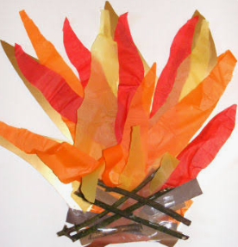 | Pretend you are Samuel Pepys watching the fire. Draw or write what you can see, hear and smell.  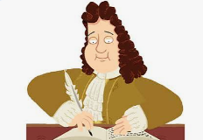 | 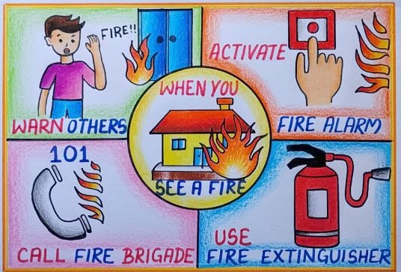  Create a fire safety poster

