Lea Primary School Topic Web Maple Class 2026 (Year 1& 2)
Autumn Term 2026
FIRE! FIRE! London’s Burning!

Year 2
Why did the Great Fire of London spread so quickly?
As Historians, we will be learning about the Great Fire of London and what happened, why it spread so quickly and how it changed city.

As Geographers, we will locate London, River Thames, and compare London from 1666 with modern day London.

As Artists we will be using a range of materials to design a picture depicting London during the Great Fire.

As Musicians, we will be learning to move in time with the beat/pulse and chant, rap and sing using different voices.

In RE, we will be learning about what it means to belong to a faith community.

In PSHE we will be learning how to safe.

In PE on Wednesdays, we will be learning how to attack, defend and shoot with an external provider. On Fridays, we will be concentrating on our foundational skills of flexibility, balance and coordination.

As Computer Scientists we will be exploring the world of digital art.

As Writers, we will be listening to stories and learn to write simple phrases and sentences, developing into more complex sentences suing describing words and joining ideas with ‘and’ and ‘because.’
We will retell the stories, create our ideas to adapt the story, as well as writing about the characters and settings. We will continue to focus on building sentences orally and rehearsing them before we record them. We will work to use capital letters, full stops and forming our letters correctly as well as beginning to work to write a short passage fo sentences more independently. We will also listen to poems and then create our own Autumn poem, thinking about our senses and what we can see, hear etc.
Lastly, we will look at different kinds of fact files linked to the characters or settings of our focus stories and build our own fact files.
In our Year 2 phonics and spellings sessions, we will be recapping Phase 5 sounds and then moving onto spelling rules for the remainder of the term.

As Mathematicians, we will continue to develop our number sense from year 1. We will learn to count in tens and add and subtract within 20. This will be a stepping stone to then add and subtract with numbers within 100. All activities will have very small steps and lots of practical activities and games to reinforce key learning. At the end of term we will start to look at putting objects into groups as we start to look at the 2, 5 and 10 times tables.

As Scientists, we will be learning about materials – exploring which materials are suitable for different uses and how their properties help them.

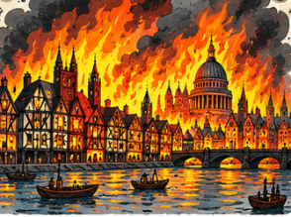

-
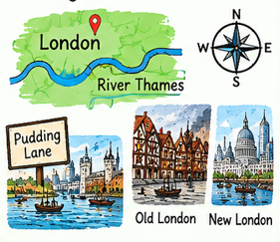
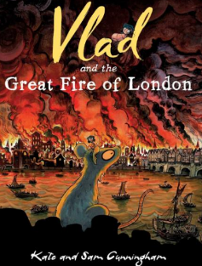


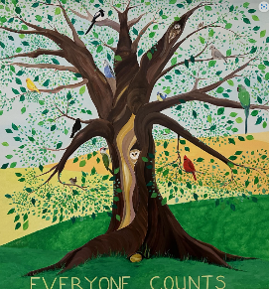
Our Christian Vision and Values

‘Everyone Counts’

Termly Focus Values: Thankfulness & Trust

