Lea Primary School Topic Web Maple Class 2026 (Year 1& 2)
Autumn Term 2026
FIRE! FIRE! London’s Burning!

Year 1
Why did the Great Fire of London spread so quickly?
As Historians, we will be learning about the Great Fire of London and what happened, why it spread so quickly and how it changed city.

As Geographers, we will locate London, River Thames, and compare London from 1666 with modern day London.

As Artists we will be using a range of materials to design a picture depicting London during the Great Fire.

As Musicians, we will be learning to move in time with the beat/pulse and chant, rap and sing using different voices.

In RE, we will be learning about what it means to belong to a faith community.

In PSHE we will be learning how to safe.

In PE on Wednesdays, we will be learning how to attack, defend and shoot with an external provider. On Fridays, we will be concentrating on our foundational skills of flexibility, balance and coordination.

As Computer Scientists we will be exploring the world of digital art.

As Writers, we will be listening to stories and learn to write simple phrases developing into simple sentences.
We will retell the stories, create our ideas to adapt the story, as well as writing about the characters and settings. We will continue to focus on building sentences orally and rehearsing them before we record them. We will work to use capital letters, full stops and forming our letters correctly. We will also listen to poems and then create our own Autumn poem, thinking about our senses and what we can see, hear etc.
Lastly, we will look at different kinds of fact files linked to the characters or settings of our focus stories and build our own fact files.
In our Year 1 phonics, we will be recapping Phase 3 sounds and then moving Phase 5 sounds for the remainder of the year.

As Mathematicians, we will continue to develop our number sense from reception. We will build on recognising numbers to 10, then 20. We will count forward and backwards as well as making amounts with all sorts of objects. We will recap how to form the numbers when writing them, too. We will also learn to find one more and one less within ten and then 20.

As Scientists, we will be learning about materials – exploring which materials are suitable for different uses and how their properties help them.

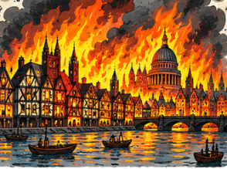

-
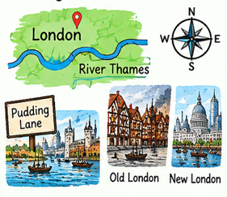
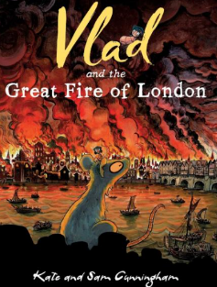
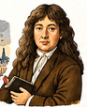

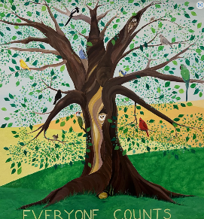
Our Christian Vision and Values

‘Everyone Counts’

Termly Focus Values: Thankfulness & Trust

