Summer 2026 - Toys from the past Y1
As Artists, we will be exploring the use of clay and different techniques that can be used to create a pinch put. This will include smoothing, rolling, pinching and the use of scoring and slip to attach elements.
As Musicians, we will be continuing to explore the rhythms within the reggae genre.
In RE, we are exploring what Christians believe god is like.
In PSHE, we will be exploring relationships, including how to be healthy, celebrating what makes us unique and how we change.
In PE, we are developing our movement skills through dance and hit, catch and run. We are exploring simple dance movements and we are practising throwing, catching, striking and moving into space while building confidence and teamwork.
As Computer Scientists, we are learning about data and information. We are grouping and labelling objects, counting them, and sorting them in different ways. We are then using this to help us answer questions about data.

As Writers and Editors, we will strengthen our understanding of how to compose interesting, grammatically correct sentences for different purposes. We will practise using commas in a list, recalling events, and giving opinions using conjunctions to explain our ideas. Building on this knowledge, we will write in a range of forms, including poetry, play scripts, and stories.
As Mathematicians, we will be looking deeper at numbers to 20, really solidifying our understanding of the basics of number. We will also begin to explore coins and time.
As Scientists, we will be exploring microhabitats. We will be identifying different habitats, observing minibeasts, and understanding how living things depend on their environment.
As Historians, we are learning about the history of toys. We are exploring toys from the past and present, comparing how they have changed over time, and understanding what toys can tell us about people’s lives.

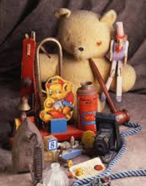
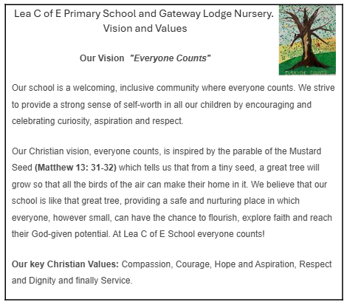
Our values this term are Friendship and Respect
As Artists, we will be exploring the use of clay and different techniques that can be used to create a pinch put. This will include smoothing, rolling, pinching and the use of scoring and slip to attach elements.
As Musicians, we will be continuing to explore the rhythms within the reggae genre.
In RE, we are exploring what Christians believe god is like.
In PSHE, we will be exploring relationships including how to make good friendships and how to solve disagreements.
In PE, we are developing our movement skills through dance and hit, catch and run. We are exploring simple dance movements and we are practising throwing, catching, striking and moving into space while building confidence and teamwork.
As Computer Scientists, we are learning about data and information. We are grouping and labelling objects, counting them, and sorting them in different ways. We are then using this to help us answer questions about data.

Our values this term are Friendship and Respect
As Writers and Editors, we will strengthen our ability to create engaging, grammatically correct sentences for different purposes. We will learn how to use apostrophes accurately for both possession and omission and apply this knowledge in our writing. We will also practise using commas in a list, recalling events, and giving opinions using conjunctions to explain our ideas. Building on everything we have already learned, we will write in a range of forms, including poetry, play scripts, and stories.
As Mathematicians, we will start to explore division and will develop our knowledge of multiplication. We will also look at fractions, money and time.
As Scientists, we will be exploring microhabitats. We will be identifying different habitats, observing minibeasts, and understanding how living things depend on their environment.
As Historians, we are learning about the history of toys. We are exploring toys from the past and present, comparing how they have changed over time, and understanding what toys can tell us about people’s lives.

Summer 2026 - Toys from the past Y2

