Lea Primary School Medium Term Planning Maple Class 2023

**As Writers and Editors**, we will continue to practise the skills we have previously learnt. Ensuring sentences are demarcated in the correct manner to show if they are a statement, question, exclamation or command across different styles of writing, starting with biographies. As well as using literacy resources such as dictionaries and thesauruses to edit and improve. In addition, we will be looking specifically at ensuring that we consistently use the correct tense within our writing; being introduced to both past and present progressive tense and using appropriate conjunctions to express time.

**As Mathematicians**, we will be covering three topics across the term: fractions, time and finally, mass and capacity. Children will have opportunity for hands-on manipulation with resources to encourage a deeper routed understanding of the taught concepts which will be applied to reasoning and problem solving exercises. We will continue to integrate the four mathematical concepts throughout lessons to ensure life-long learning.

**As Scientists**, in the first half of term we will be exploring plants. Children will have hands-on exploration time to discover the different parts of flowering plants, as well as observing the requirements of plants for life and growth through experimentation. Next half term, we will be learning about animals, including humans. Looking specifically at nutrition and the skeletal system. By working scientifically, children will draw comparisons and contrasts about movement of animals with and without skeletons as well as their diets.

This topic is primarily geography based however links to **history** skills will include looking at changes in local land use and transportation over time.

**As Geographers**, children will be exploring the local area around Lea, including nearby towns and cities. We will look at the differences between human and physical geographical features including buildings, land use and transportation links. Through fieldwork and observations children will produce maps and devise simple keys.

**As Artists**, we will be expanding the range of materials we work with to create sculptures, inspired by the work of local artist Walenty Pytel.

**In RE**, children will be exploring the ‘good news’ Christians believe that Jesus brings in the first half of term. In the second half of term, close links will be made to the school values as children discuss how and why we should care for the world, and others around us.

**In PSHE**, children will be discussing relationships, including the importance of boundaries, heathy friendships and family bonds in the first half of term. During the second half of term, children will explore the changes that are happening in their world.

**In PE**, on Tuesdays swimming lessons will continue for 2 more weeks and on Fridays the children will have Tennis coaching with Activate Sports.

**As Computer Scientists**, in the first half of term we will be looking at how we can manipulate music digitally to change the pattern, tempo and sound. After half term, we will be making our own online quizzes using previously learnt programming skills.

Mrs Webber will continue to teach **French** lessons in the first half of term, where the children will learn about seasons and key places in towns. In the second half of term, French will be replaced by **Music** where children will continue to compose and perform music with an emphasis on timbre.

**Summer Term 2023**

**Life around Lea**

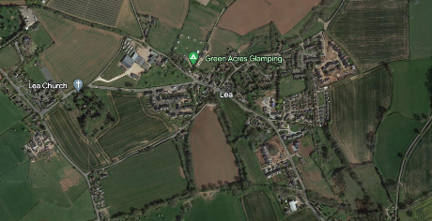blockpage[2]

blockpage[1] blockpage[1]

blockpage[2]blockpage[1]



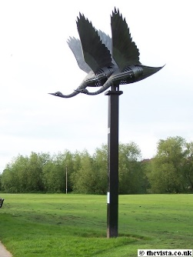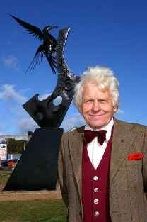

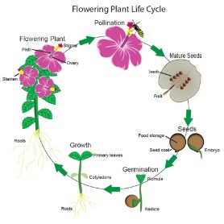 blockpage[1]

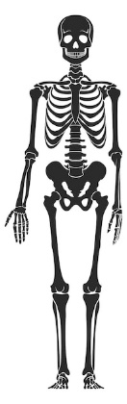

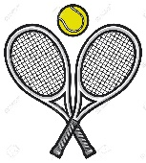

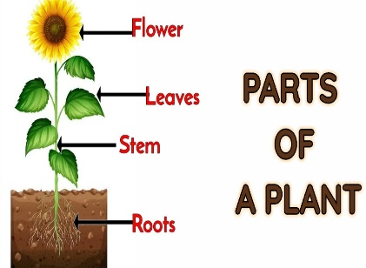

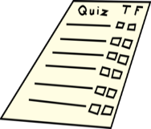

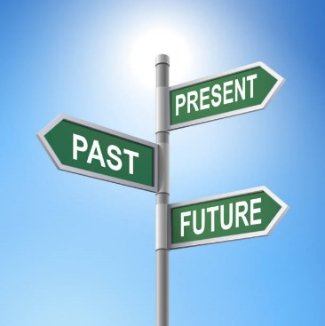

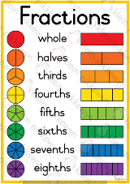

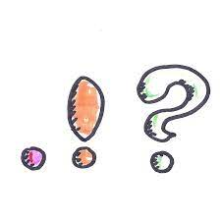

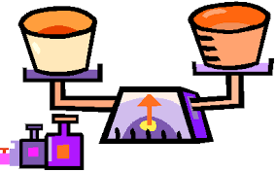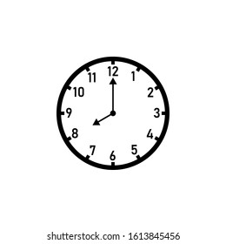

Throughout the term, the school values we will be concentrating on are service and truthfulness.

Children will learn how to be selfless, using their talents to help others, as well as showing that they are thankful for the beauty that is in the world around us and the opportunities they are given.