Lea Primary School Medium Term Planning Maple Class 2023

**As Writers and Editors**, we will continue to demonstrate our knowledge of sentence composition while improving the quality of our writing through building upon our understanding of numerous sentence structures including statements, questions, exclamations and commands. We will also explore more complex concepts including inverted commas, apostrophes as well as the relationships between verbs and adverbs and how this fits into our writing.

**As Mathematicians**, we will be continually developing our knowledge of multiplication, including the 3, 4 and 8 times table. Additionally, we will be exploring the relationship between multiplying and dividing and independently utilising these skills to solve problems and explain our thinking. In the second half of term, we will be studying the properties of 2-dimensional and 3-dimensional shapes, learning how to measure and draw shapes accurately as well as spotting and making patterns.

**As Scientists**, we will be exploring forces and magnets. Children will identify forces that act on direct contact and make comparisons against the way in which magnetic forces work. Working scientifically, children will observe patterns in the way magnets attract and repel one another, as well as everyday materials and begin to classify objects. From this, children will be able to make predictions about further materials based upon their properties.

This topic is, again, history based however links to **geography** skills will include looking at human and physical features of Stone Age civilisations, the land use and how this has changed over time.

**As Historians**, we will be transporting ourselves back to what life was like in the Stone Age. Children will learn about the impact had on Britain between the time of the Stone Age and Iron Age, thinking specifically about living conditions, use of materials and early forms of communication.

**As Artists**, we will develop our skills in colour, texture and shape inspired by the work of American artist, Carol Sabo, who is renowned for her acrylic and watercolour silhouette sunsets.

**As Musicians**, children will listen to a range of musical compositions, further developing their understanding of musical structure alongside

singing, playing, composing and performing their own pieces.  **In RE**, in the first half of term we will be exploring the Muslim faith, their beliefs and ways of life. During the second half of term, we will be discussing Easter and why it is important to Christians.

**In PSHE**, we are identifying our dreams and goals, talking about aspirations and how to achieve them. Next half term, we will be discovering how to be the healthiest versions of ourselves.  
 **In PE**, we will be concentrating on running, jumping and throwing skills alongside enhancing our co-operation skills to improve our play in team sports. On Thursdays we will be incorporating our newly learnt skills into Handball.

**As Computer Scientists**, we will be learning about algorithms; how to provide simple instructions to programme a robot. We will also be looking at pictograms as a way of presenting data.  
We will also be continuing **French** lessons with Mrs Webber on a Wednesday afternoon learning about fruit and vegetables whilst consolidating knowledge of numbers and colours.

**Spring Term 2023**

**Welcome to the Stone Age**

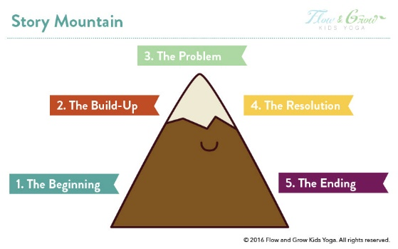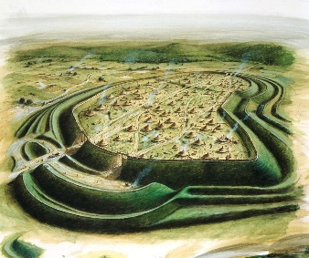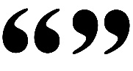

 



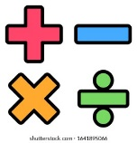

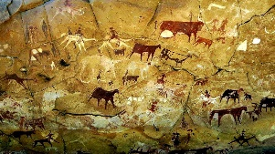



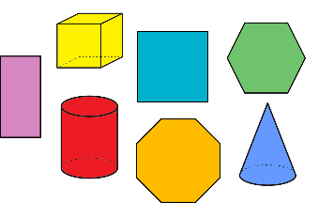

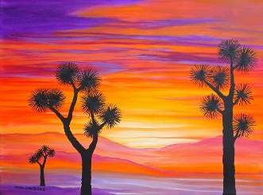

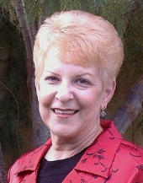

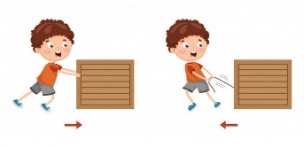

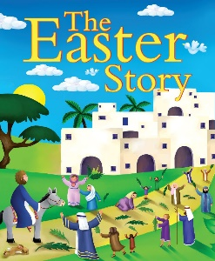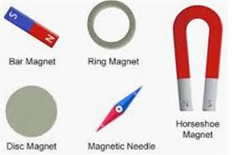

This term, the values we are looking at are perseverance and justice. Children will learn to be resilient and push through when things become difficult as well as becoming acquainted with the idea that goodness is stronger than evil.