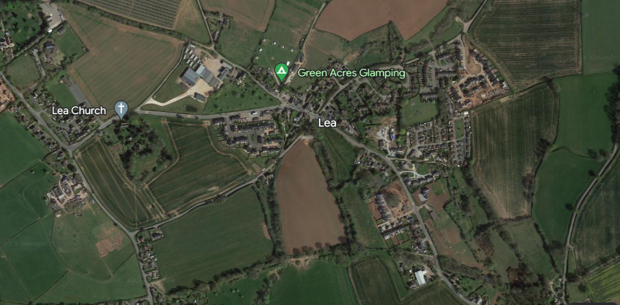
Maple Class Homework
Summer Term 2023
*Who lives in your house?
What are their ages?
Can you add 2 of these numbers together?
Can you add them all together?
Can you subtract one from another?
What other mathematical operations can you do with these numbers?*
Life around Lea
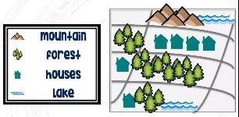
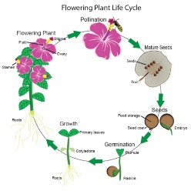
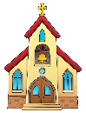

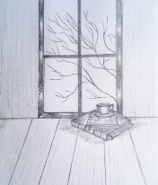
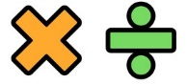
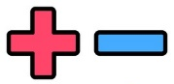
Draw a map of the area where you live. Remember to make a key to label all of the important features.
*Write a setting description of the area where you live. Can you use expanded noun phrases?*
Create a 3D model to demonstrate the life cycle of a flowering plant.
Create a table to document how many human and physical geographical features you see on your way to school.
Sketch the view you see of outside.
This could be in your garden, from your bedroom window, in the car, on the bus, on a weekend trip, anywhere!
Remember, sketching is light, rough and has no colour. No rubbers!

READ ALL ABOUT IT!
Pretend you are a news reporter. You have been hired to encourage children to come to Lea Primary School.
Write an article describing all the reasons why someone should come to our school.
Remember to organise your writing into paragraphs!

Information for Children and parents / carers.
Alongside daily reading, throughout the next term you have been asked to complete as many of the above activities as possible! The activities marked with an * are deemed compulsory, the others are recommended activities to further children’s understanding, and deepen their engagement with, the current learning topic. We strongly encourage that any completed homework is brought into class to be acknowledged, and celebrated, with peers to promote a sense of pride and achievement within children. All homework completed will be monitored; children who complete homework throughout the term will be entered into a class prize draw!
As always, if you require any additional resources, please let us know and we will aim to provide these.
Thank you for your support.

