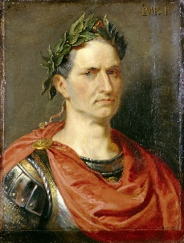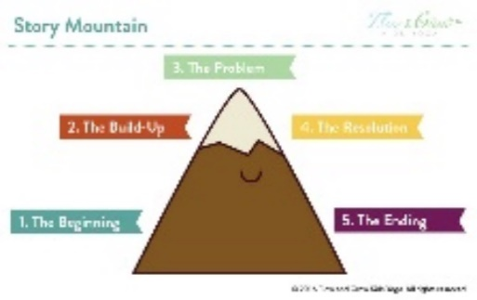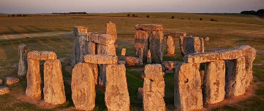 Maple Class Homework   
 Spring Term 2023

*Complete the attached multiplication mosaic! *

Design a civilisation.

Where will you sleep?  
How will you stay safe?  
Where will you source food and water?

*Complete a character description for Julius Caesar.

What was his appearance like?  
What might his personality have been like?  
Where did he live? *

*Shape hunt!

How many 2D and 3D shapes can you find around your home?

Keep a tally to record how many you find. *

*Plan and write a short story entitled ‘A day in the life of a Stone Age man’

Who is your character?  
Where is your story set?  
What problem might they face?  
How can they resolve it?  
What happens in the end?

Illustrate it with your own cave paintings! *

The construction process of Stonehenge started during the Bronze Age and took over 1500 years to build!

How long will it take you to produce a 3D replica of Stonehenge?

How many days did it take you? How many hours? How many minutes?

The Stone Age man is in C,1. He wants to get to D,5.   
Can you help him?

Write a list of simple instructions to help him reach his goal.

Use terminology like left, right, up, down, North, South, East and West!

How many different ways can he get there?

Homework guidance for Children, Parents and Carers

Alongside daily reading, throughout the next term you have been asked to complete as many of the above activities as possible! The activities marked with an * are deemed compulsory, the others are recommended activities to further children’s understanding, and deepen their engagement with, the current learning topic. We strongly encourage that any completed homework is brought into class to be acknowledged, and celebrated, with peers to promote a sense of pride and achievement within children. All homework completed will be monitored; children who achieve 8 or more pieces of complete homework throughout the term will be entered into a class prize draw!

As always, if you require any additional resources, please let us know and we will aim to provide these.

Thank you for your support.

**Welcome to the Stone Age**

**Programming** – Giving simple instructions to achieve a goal.  
Help the Stone Age man reach his chosen destination!

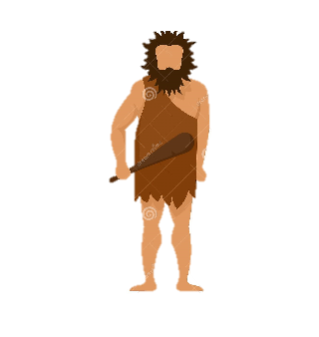

___________________________________________________________________________________________________

___________________________________________________________________________________________________  
  
 ___________________________________________________________________________________________________  
  
 ___________________________________________________________________________________________________  
  
 ___________________________________________________________________________________________________  
  
 ___________________________________________________________________________________________________

Complete the multiplications and colour in the mosaic using the key below to discover the hidden image!

Multiplication Mosaic

**Challenge!**  
Complete the inverse operation for the fact families in the multiplication mosaic.

Multiplication Mosaic

Complete the multiplications and colour in the mosaic using the key below to discover the hidden image!

**Challenge!**  
Complete the inverse operation for the fact families in the multiplication mosaic.