Rowan Class Home Learning
Macbeth- 1-5.6.20

Activity 2

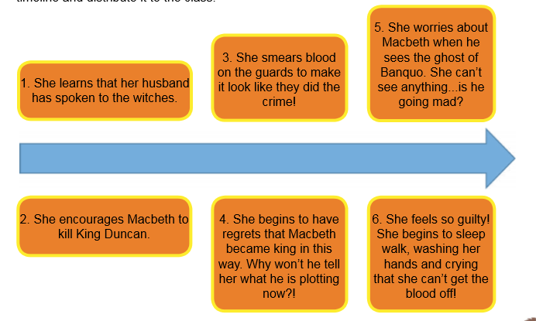

The timeline shows Lady Macbeth’s actions during the story.
Write a letter as if you were Lady Macbeth writing to Macbeth, telling him how sorry she is; how much she regrets everything she has done and begging him to stop his reign of terror and confess all.

Activity 3
Watch Clip 8:’Birnam Wood Comes to Dunsinane’ https://www.bbc.co.uk/teach/school-radio/english-ks2-macbeth-8/zvnd92p
Then read on to the end of the book.
Vocabulary Focus:
- Find and copy a word on page 54 that means the same as ‘hide’.
- Find and copy a word on page 54 that means the same as ‘tricked’.
Inference Focus:
- What might Macbeth be thinking and feeling when he learns of Lady Macbeth’s death?

- What might Macbeth be thinking and feeling when he hears the soldiers are advancing on page 54?

Explanation Focus:
- Explain why Macbeth ignores his generals’ pleas to go to battle.
- Can you use the information on page 54 to explain what the witches said to Macbeth on page 47?
- Explain why Macbeth shouts, “You were born of a woman!” as he fights the soldiers.
- Explain how the prophecy has come true.

Activity 4
Retrieval Focus
- Complete these sentences with the missing words: The day after Lady Macbeth’s __________, a captain brings __________ news to Macbeth. The enemy are ____________ and to _________ their numbers they are using __________ from _______________.

- Why do Macbeth’s soldiers give up so easily?
- Who finally kills Macbeth and how?

Summarising Focus:
The following is an extract from Macbeth’s famous speech in the play by Shakespeare’s play. (A long speech by one character in a play is called a ‘soliloquy’.)

Out, out, brief candle!
Life's but a walking shadow, a poor player
That struts and frets his hour upon the stage
And then is heard no more: it is a tale
Told by an idiot, full of sound and fury,
Signifying nothing.
Use this extract and also page 53, to write a diary entry as if you were Macbeth, to summarise how he feels at the moment.
Perhaps you could try performing this soliloquy, as if you were Macbeth?

Activity 5
Choose either your diary entry or your letter to edit. Then produce a final draft, and send it to me to read.

In preparation for our final week on Macbeth next week, I would like you to reread the story. You may want to watch the clips again as well.

