Rowan Class Home Learning
15-19.6.20
English
Activity 1
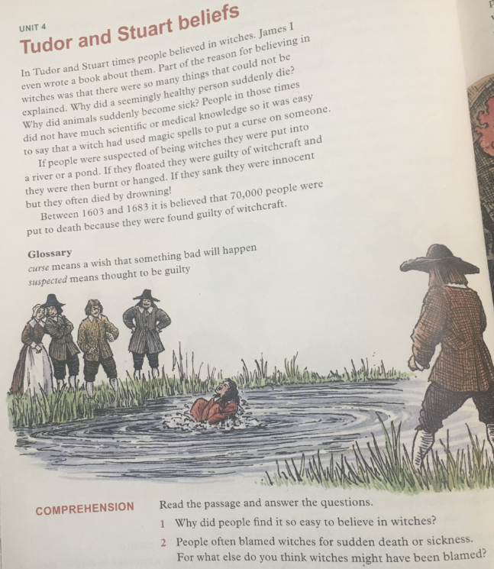

Activity 2
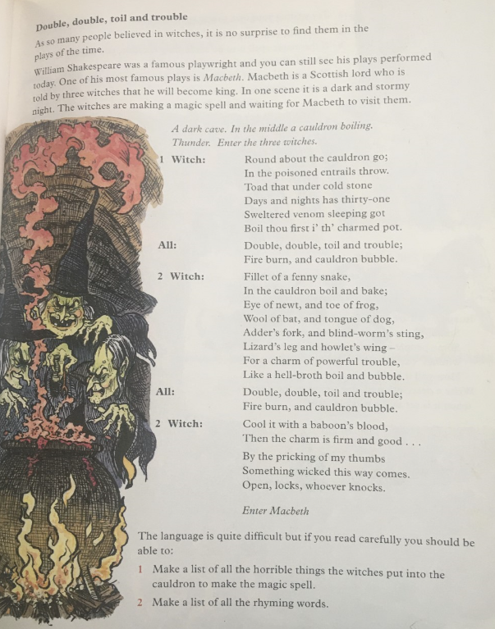

Activities 3 & 4
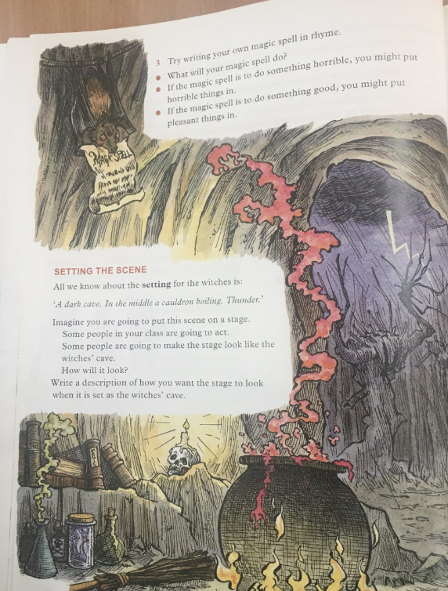

Activity 5
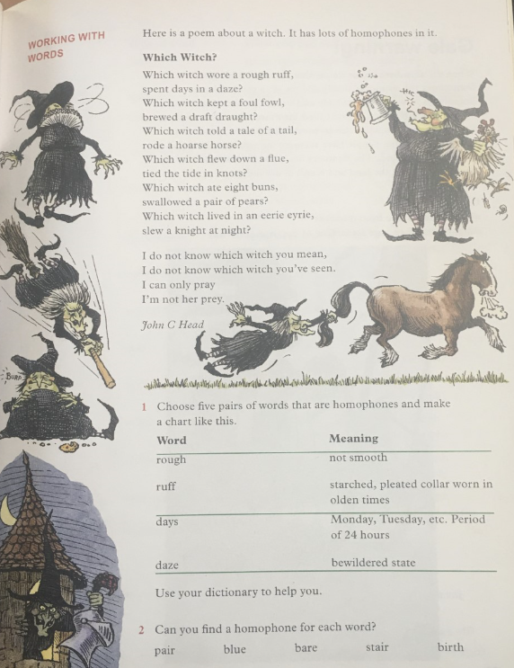

Next week we are going to begin studying another play by William Shakespeare: “A Midsummer Night’s Dream”. Why not begin to do some research about the play and its characters?

